TABLEAU ASSIGNMENT

CITI BIKE ANALYSIS

**Author**: Vaishali Tanwar

**Citi Bike Analysis:**

* **Phenomenon 1:** Trend of Ridership from Jan 2020-May 2020
* The ridership has increased from 1,240,596 in January 2020 to 1,487,890 in May 2020, although we see that the week wise ridership has decreased from first week of January to last week of May.
* Although we see a major drop in the number of rides taken in the month of April, we see that the average trip duration has been increasing. Major drop in the month of April can be due to the lockdown imposed as a safety measure to protect from COVID 19.
* The number of annual members i.e. the subscribers have decreased from January to May reason being the lockdown and many office places and schools are now following work from home culture and online classes. At the same time, we see an increase in the number of customers (24-hour pass or 3-day pass users) towards the end of April as slowly relaxations are being imposed on the lockdown and people are coming back to normal life.
* Males who contribute to larger percentage to the ridership although show a decrease in number from January to May but the number of female riders show an increasing trend compensating the overall statistics.

**Overall, we see an increasing trend in the ridership of Citi Bike from Jan 2020 to May 2020.**

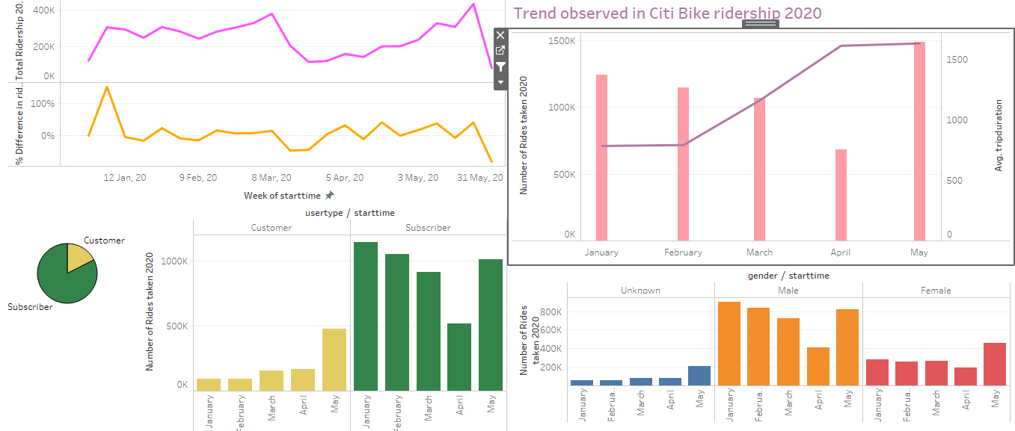

* **Phenomenon 2**: Top 10 stations in the city for starting a journey:
* The top 10 stations for starting a journey are:

1. Perishing Square North
2. W 21 St and 6 Avenue
3. E 17 St and Broadway
4. West St and Chambers St
5. Broadway and W 60 St
6. Broadway and E 22 St
7. 12 Ave and W 40 St
8. 1 Ave and E 68 St
9. Christopher St and Greenwich St
10. 8 Ave and W 31 St

* A large number of riders start their journey from the stations listed above and their popularity can be seen in each month from January 2020 to May 2020.
* The ridership at stations Perishing Square north and 8 Ave & W 31 St show a significant drop. The ridership count at Perishing Square North drop from 10,734 in Jan to 2,838 in May but that is because of the COVID 19 lockdown imposed. But the numbers have already picked up from 1,492 in April to 2,838 in May still making it most sought after due to its location near Grand Central Terminal as the lockdown rules have been relaxed. A similar situation can be seen in case of 8 Ave & W31 St.
* The availability of maximum number of bikes at the above listed stations makes them a popular choice.
* The subscribers (annual members) who form major chunk of riders using the Citi Bike can be seen contributing a large percentage of people starting their journey from the above stations. This shows that regular riders often start their journeys from these stations.

**Hence, the above listed stations are amongst the top ten popular stations for starting a journey in the city.**

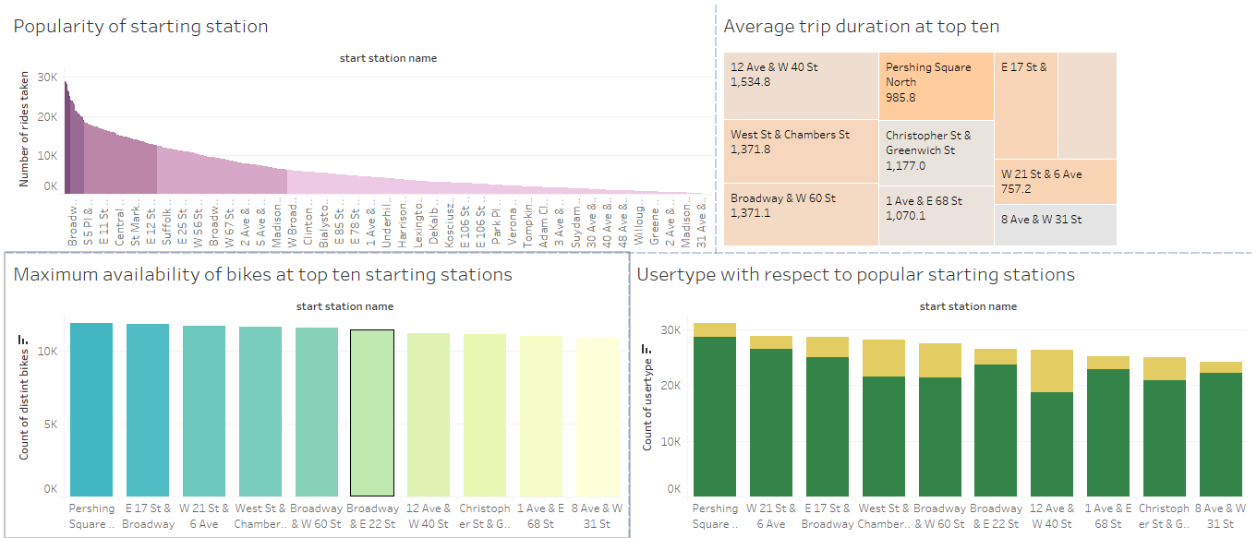

* **Point observed while plotting the Static Map:**

The stations popular for starting the journey are also popular for ending the journey in the city

